Online Quiz System with Facial Recognition

Tengxiaoyao Tu, Zhicheng Pan, Chao Zhang, Hang Zhou, Yunpeng Bai

School of Computer Science

University of Windsor

Windsor, ON, Canada

{tu6,pan14,zhang1pr,zhou167,bai11e}@uwindsor.ca

ABSTRACT

The current methods for verifying the identity of examinees are subjective and inefficient. In this project, we have done research on methods currently used in face recognition related industries to do verification, studied on how it can be implemented smoothly and efficiently with the online quiz system, made improvements. The system include all basic functions that a regular Courses Registration System may have. Moreover, it will use web cameras to catch images of a student’s face and identify his permission to login the system. By using the Agile methods, we have real-time communication among team members regularly. Coders pair with each other; pairing programming is practiced throughout the whole project. As a result, we minimize the risk during the design and development of the Quiz System and successfully integrate it with facial recognition.

1 INTRODUCTION

With the maturity of search technologies and the rapid development of artificial intelligence nowadays, biometric identification technology is gradually showing its high commercial value and market prospect. The perfection and popularization of hardware have paved the way for the development of intelligent software, and the superiority of AI technology has gradually emerged in various fields, such as web application. In this report, the goal is to introduce how a web application named Online Quiz System which combines facial recognition is developed.

Regarded as an important subsystem of a school ERP system, Online Quiz System plays an important role in helping schools and training institutions to allocate teaching resources and maximize students' and instructors' utilization. It not only features with traditional functionalities of Online Quiz System but also integrates the latest technologies of continuous biometric authentication when users are doing the quiz.

This report covers fore sections: Project Details and Methodology Section which gives information about the definition of the system, the methodology used to develop the entire system, the architecture including system architecture and module description, the platform and the design; Experimental Setup Section indicates implementation details, work breakdown structure, testing and findings, Challenges. Finally, conclsion is

2 PROJECT DETAILS AND METHODOLOGY

2.1 Definitions

Current facial recognition systems are functional [computer application](https://en.wikipedia.org/wiki/Application_software)s being able to identify or verify users from a live [digital image](https://en.wikipedia.org/wiki/Digital_image) or a [video frame](https://en.wikipedia.org/wiki/Film_frame) from a [video](https://en.wikipedia.org/wiki/Video) source. One of the ways to do this is by comparing selected [facial features](https://en.wikipedia.org/wiki/Face) from the image and a face [database](https://en.wikipedia.org/wiki/Database_management_system). It is typically used in [security systems](https://en.wikipedia.org/wiki/Burglar_alarm) and can be compared to other [biometrics](https://en.wikipedia.org/wiki/Biometrics) such as [fingerprint](https://en.wikipedia.org/wiki/Fingerprint) or eye [iris recognition](https://en.wikipedia.org/wiki/Iris_recognition) systems. [[1]](https://en.wikipedia.org/wiki/Facial_recognition_system#cite_note-Animetrics-1) Recently, it has also become popular as a commercial identification and marketing tool.[[2]](https://en.wikipedia.org/wiki/Facial_recognition_system#cite_note-2)

Face recognition for user authentication comprises two main steps, namely the face detection and recognition. The difficulties in face detection mainly come from two aspects: 1) the large visual variations of human faces in the cluttered backgrounds; 2) the large search space of possible face positions and face sizes. Existing schemes may not be effective for faces due to small-sized faces, lighting and complex appearance variations, i.e., face recognition for unconstrained video-surveillance environments is a highly demanding task, and needs several pre-processing to be usable. [3]

2.2 Methodology

The project will be accomplished with incremental development and XP based on agile development methodology. The project aims to develop a basic course system featured with a login module utilized face recognition technologies, and it will be finished in 8 weeks and by a team of 5. The most important purpose of this project is to use suitable software engineering methodology to build a completed system.

2.2 Specification

*2.1.1* Registration

Users that don't have an account or have lost the account may register. When they click on register button, it will go to register page and users need to fill in date of birth, address, gender, email, first name, last name, username and password to get an account. Email and username should be distinct. And username will be encrypted by MD5 encryption, then send to the database. If the email and username input are not repeated, meet the basic requirements and the user click the submit button, the account is created and saved into the database. At the same time, the user will be taken two pictures in order for instructor to verify the identity of the user when doing the quiz later.

*2.1.2* Login

After creating an account, users may login the system. When they click on login button, it will go to register page. Users have two ways to login. They can fill in username and password or open the camera to take a new picture. If users choose to login by username and password, click the submit button and the username-password combination matches with another one in the database, user will login the system. If it doesn’t match, user may do it again until they make a correct match. If users choose to login by taking a picture, the system will compare the new picture with all the pictures in the database. If it doesn’t match, users will not be allowed to login until they give a face picture recognized by the system.

*2.1.3* Course

After creating users’ login, users now have access to the system as a valid user and are present with the index page. When they click on add a course button, it will go to course selection page. Then they are entitled to add a course by either a course number or a course name. If the course number or the course name matches another in the database, user will add the course. If it doesn’t match, user may do it again until they make a correct match.

*2.1.4* **Quiz**

After adding a course, users now have access to that specific course if approved and they can that course shown in the course list page. When they click on that course’s button, it will go to that course’s home page. After the instructor give a quiz online, they are required to do that quiz by clicking the quiz button . If the instructor doesn’t specify the number and content of the quiz, the user will be presented with 10 random quiz questions in 10 minutes. At the same time, the continous facial recognition is ongoing. After the user finishes the quiz and clicks the submit button, the system will automatically grade the quiz if questions are all objective.

***2.1.5* Facial Recognition**

Current facial recognition systems are functional [computer application](https://en.wikipedia.org/wiki/Application_software)s being able to identify or verify users from a live [digital image](https://en.wikipedia.org/wiki/Digital_image) or a [video frame](https://en.wikipedia.org/wiki/Film_frame) from a [video](https://en.wikipedia.org/wiki/Video) source. One of the ways to do this is by comparing selected [facial features](https://en.wikipedia.org/wiki/Face) from the image and a face [database](https://en.wikipedia.org/wiki/Database_management_system). It is typically used in [security systems](https://en.wikipedia.org/wiki/Burglar_alarm) and can be compared to other [biometrics](https://en.wikipedia.org/wiki/Biometrics) such as [fingerprint](https://en.wikipedia.org/wiki/Fingerprint) or eye [iris recognition](https://en.wikipedia.org/wiki/Iris_recognition) systems. [[1]](https://en.wikipedia.org/wiki/Facial_recognition_system#cite_note-Animetrics-1) Recently, it has also become popular as a commercial identification and marketing tool.[[2]](https://en.wikipedia.org/wiki/Facial_recognition_system#cite_note-2)

Face recognition for user authentication comprises two main steps, namely the face detection and recognition. The difficulties in face detection mainly come from two aspects: 1) the large visual variations of human faces in the cluttered backgrounds; 2) the large search space of possible face positions and face sizes. Existing schemes may not be effective for faces due to small-sized faces, lighting and complex appearance variations, i.e., face recognition for unconstrained video-surveillance environments is a highly demanding task, and needs several pre-processing to be usable. [3]

In this project, When the user is given the quiz, they are responsible for opening the camera and showing the face without leaving the camera’s reach. The camera will first catch one picture of the user and then take one after each ten seconds repeatedly. The system will continuously match the new picture with the two pictures taken when they register. If the camera can not catch their faces, it will automatically warn the user to check the camera or move the face back to the camera. When the camera catches another user’s face or warn the user three times, chances are that the user is cheating or trying to cheat, the system will shut down the quiz, record the user and course, inform the reason and regulations, and send the user back to the course home page. Only after the instructor permit and delete that record on instructor’s account can the user be released and do a new quiz with totally different questions.

2.3 Architecture

2.3.1 System Architecture

Figure 1: Entity Relationship Diagram

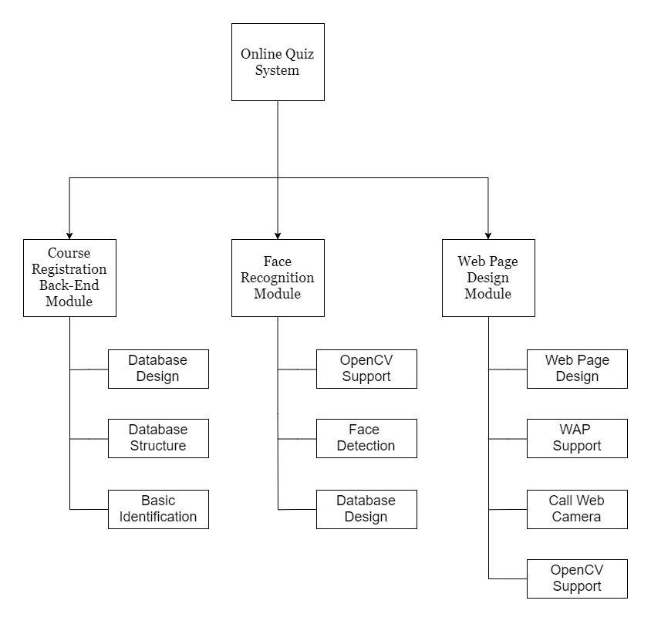

2.3.2 Module Description

1. name 1…

It is a …., use to ….

2. name 2…

2.4 Platform

*2.4.1* On IDE side, for the programming environment’s consistency and compatibility, IntelliJ-IDEA from JetBrains is used for all developers.

*2.4.2* On Cloud side, IBM Bluemix and CloudFoundry are used to deploy the application.

*2.4.3*For the project’s stability and integrity, the system is designed to be based on Spring Boot framework to basically build B/S server with key technologies including Restful and AJAX used.

2.5 Design

Figure 1: Entity Relationship Diagram

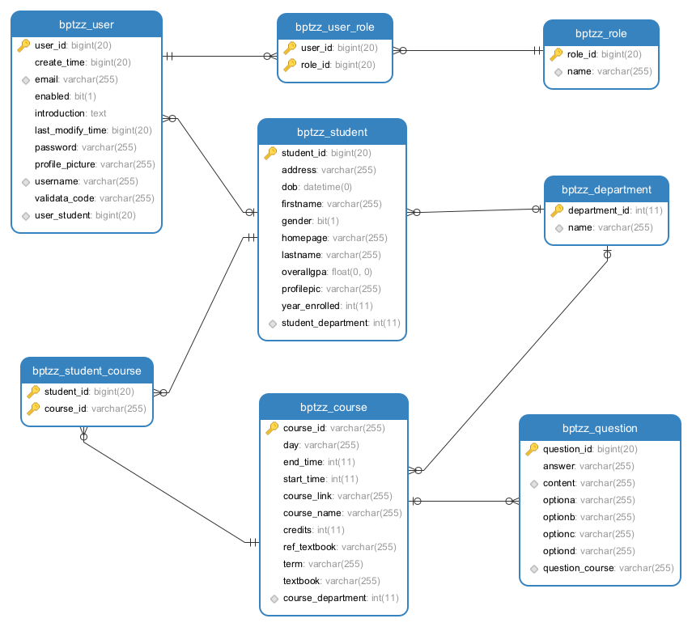

*2.5.1*The project is required to directly gain the data stream of the web camera from web client side, with key technologies including HTML5, Thymeleaf and AJAX used to gain data.

*2.5.2* The server is required to process bio-data and identify users with OpenCV3.3 class libraries called to implement facial recognition and image comparing.

*2.5.3* Hibernate is used as a tool for persistently object-relational storage and query, with AJAX completing front-end and back-end fast interaction of data.

*2.5.4* This project is coursework project of Software Engineering with MySQL database used to both improve portability and reduce the complexity of database environment configuration.

3 EXPERIMENTAL SETUP

3.1 Implementation Details

Table 1: Schedule and Milestones

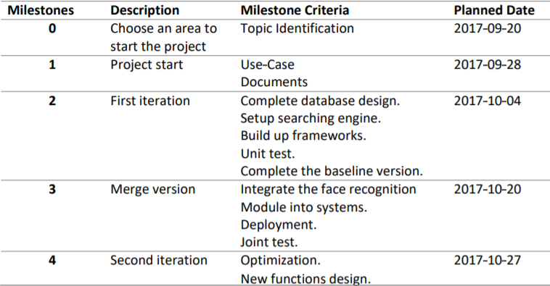

Figure 2: WBS(Work Breakdown Structure) for the First Version

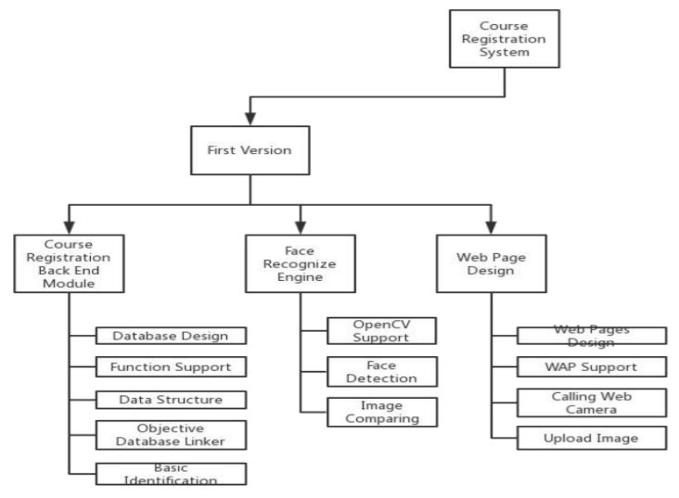

Figure 3: Gantt Chart of the Project Schedule



We develop a course selection system which helps students select courses and manage records. Meanwhile, facial recognition in a biometric way is required to authenticate students’ and teachers’ login. This system is required to be back-end manageable; system administrators can configure several key settings; teachers can use the system to call the roll; students can log in, access classes, manage personal information and query test results through facial recognition and authentication. The project is accessible on both mobile phones and web pages.

3.2 Testing

Table 2: Sample User Test Cases

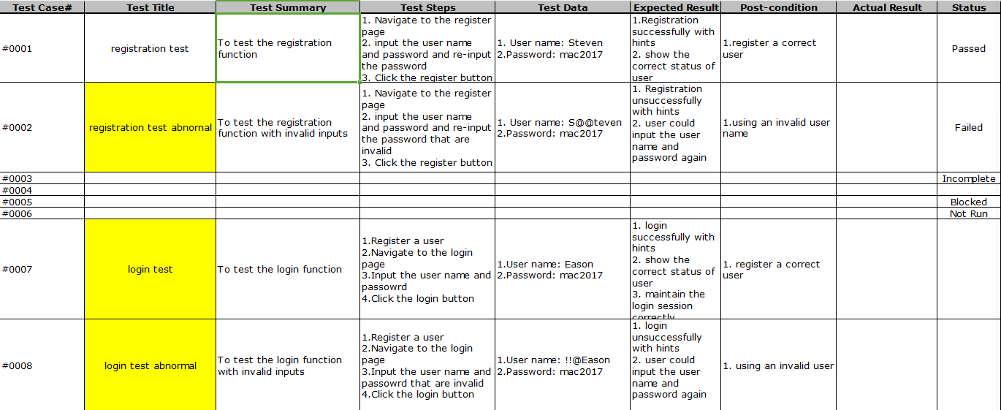

Regarding testing, we strictly follow the testing lifecycle and principles introduced in software engineering course. We develop 20 test cases that use both white box testing and black box testing cases. Besides, unit testing is used by which minimal individual units, sets of system modules together with associated control data, usage procedures, and operating procedures, are tested to determine whether they are fit for use. [4]

3.3 Findings, and Challenges

Although the project is an existing system, it is an innovative project since it seamless integrates and utilizes the latest technologies that could easily defeat the current and regular system. Face recognition can be applied in various fields, and it is the most mature sub---area of AI. It is ready to be commercially launched. Theoretically, it could be used in any system with authentication modules or replace the old fashion authentication module. Its potential customers are those who will newly launch a brand new Courses Registration System or upgrade their existed legacy system. The challenge is that the algorithm for realizing face recognition is not optimal, which can take 5 seconds per face averagely.

4 CONCLUSIONS

In summary, we have performed an experimental study on and designed the face recognition system. The experimental and designing results have been successfully that facial recognition in a biometric way authenticate online quiz, students’ and teachers’ login. We finished all planned requirements in the duration of the project, two months.

ACKNOWLEDGMENTS

We would like to express our deepest appreciation to all those who have provided us help and given us advice to complete this project and report.  We want to give a special gratitude to our Advanced Software Engineering course professor, Mr. Pooya Moradian Zadeh, whose contribution in suggestions and encouragement did great benefit to our project especially in writing this report.

REFERENCES

|  |  |
| --- | --- |
| [1] | ["Face Recognition Applications"](http://www.animetrics.com/technology/frapplications.html). Animetrics. Retrieved 2008-06-04.  http://www.animetrics.com/technology/frapplications.html |
| [2] | ["Facial Recognition: Who's Tracking You in Public?"](http://www.consumerreports.org/privacy/facial-recognition-who-is-tracking-you-in-public1). Consumer Reports. Retrieved 2016-04-05.  https://www.consumerreports.org/privacy/facial-recognition-who-is-tracking-you-in-public1 |
| [3] | Ping Wang, Wen-Hui Lin, Kuo-Ming Chao, Chi-Chun Lo. A Face-Recognition Approach Using Deep Reinforcement Learning Approach for User Authentication. [E-Business Engineering (ICEBE), 2017 IEEE 14th International Conference](http://ieeexplore.ieee.org.ledproxy2.uwindsor.ca/xpl/mostRecentIssue.jsp?punumber=8118205) Electronic. ISBN: 978-1-5386-1412-9. |
| [4] | Kolawa, Adam; Huizinga, Dorota (2007). [Automated Defect Prevention: Best Practices in Software Management](http://www.wiley.com/WileyCDA/WileyTitle/productCd-0470042125.html). Wiley-IEEE Computer Society Press. p. 75. [ISBN](https://en.wikipedia.org/wiki/International_Standard_Book_Number) [0-470-04212-5](https://en.wikipedia.org/wiki/Special:BookSources/0-470-04212-5). |